GRADUATION TRANSITION PLAN

“Dirige me in veritate tua”

Decide in your heart of hearts what really excites and challenges you, and start moving your life in that direction. Every decision you make, from what you eat to what you do with your time tonight, turns you into who you are tomorrow, and the day after that. Look at who you want to be, and start sculpting yourself into that person. You may not get exactly where you thought you'd be, but you will be doing things that suit you in a profession you believe in. Don't let life randomly kick you into the adult you don't want to become. ― Chris Hadfield

Chris Hadfield is one of the most seasoned and accomplished astronauts in the world. The top graduate of the U.S. Air Force Test Pilot School in 1988 and U.S. Navy test pilot of the year in 1991, Hadfield was selected by the Canadian Space Agency to be an astronaut in 1992. He was born in Sarnia, Ontario in August, 1959.

How to Use This Booklet
Graduation Transition Instructions

Your Graduation Transition assignment is worth 4 credits and is required for graduation. You will complete some of these assignments in your GT blocks during HACE weeks, the rest on your own time. All documents that you prepare for your GT binder must be word-processed (except you should use an Excel spreadsheet for the Budget). Some assignments must be signed by your parent and/or your teacher.

This booklet will outline what is required for you to complete the Graduation Transitions document. You should keep all of your files in a safe place and BACKUP everything to more than one computer, to a cloud, or a remote disk. No excuses for lost work on your computer! Be proactive!

Pay attention to instructions given by your GT and Homeroom teachers, especially concerning due dates and presentation dates.

What you will need:
- A computer and printer to prepare your documents (bring a laptop to advisory block classes to make your time most productive in class).
- A binder for your documents and for your presentation.
- A means of backing up your documents to a remote media. Don’t let a computer crash be your excuse for not handing work in on time.
- Your Grad Transitions booklet to guide you through the assignments.

Due Dates:
Your GT teacher and your homeroom teacher will provide you with reminders of when the sections of your GT portfolio are due. The final due date will be given to you in GT 12. Remember to keep an accurate record of your daily physical activities so that you can present your summaries throughout the year.

Plan ahead: some documents (reference letters, letters of acceptance, etc.) will become a part of your GT portfolio. Give your referees and institutions enough lead-time to enable you to include these in your portfolio.

FAILURE TO HAVE YOUR GT PLAN READY FOR YOUR PRESENTATION APPOINTMENT MAY RESULT IN YOUR FAILURE TO GRADUATE IN JUNE, OR JEOPARDIZE YOUR PARTICIPATION IN GRADUATION ACTIVITIES.

If you have any questions, see your GT teacher for guidance.

THE REQUIRED ELEMENTS OF YOUR GRADUATION TRANSITION PLAN

Each of these sections must be included in your final document for presentation. You may wish to organize your binder in this order so that it is easier to access the documents. It is suggested you create a title page as well as a table of contents for your binder.

Sections of the Graduation Transitions Portfolio

I. Career and Life
Part 1: Future Plans
Part 2: Achievements and Evidence of Growth
Part 3: Career Investigation
II. Personal Health
Part 4: Healthy Living Plan
A: Sound Nutritional Habits
B: Regular Exercise Routines
C: Emotional Health Management
D: Daily Physical Activity Reports (one per reporting period)
III. The Financial Plan
Part 5: The Budget
A: Spreadsheet of budget
B: Financial Questions
C: Parent Signature
IV: Community Connections
Part 6: Work Experience
- Supervisor’s Report
- Two reference letters
- Resume and cover letter
- Proof of 30 hours of volunteer or paid work
- Student self evaluation and reflection

Reminders: DPA Log due dates:

Report 1 – Wednesday, November 14, 2018
Report 2 – Tuesday, January 29, 2019
Report 3 – Thursday, May 16, 2019

CAREER AND LIFE
Future Plans
PART 1

Transitioning from secondary school to work, post-secondary education or travel requires some planning. Answer the following questions in full sentences in a word-processed document to give evidence that you have given some thought as to how you will make the transition.
- What are your plans after high school? (Choose one and refer to the questions below.)
- Post-secondary school
- travel in lieu of attending school or working
- work or volunteer in lieu of attending school or traveling
- combination of the above
- Based on your choice, complete the section of questions that relate to that option.
- Have your parents read your full sentence answers and sign at the bottom of your Career and Life Transition document that you word-processed. Hand in your good copy to your GT teacher by _________________________.

(a) Answer these questions if you plan to attend post-secondary school in the fall or spring term following high school.
- What post-secondary program are you planning to take?
- Which school is your first choice? Second choice?
- What are the entrance requirements needed to apply to your first choice program?
- Show evidence that you have researched the entrance requirements to your program and university of choice. Show evidence that you have met those requirements, or made plans to meet those requirements.
(b) Answer these questions if you plan to travel in the summer, fall or spring following high school (instead of attending a post-secondary school or staying home to work).
- What has influenced your decision to travel?
- What special arrangements do you have to make prior to leaving for your trip?
- What documents/vaccinations do you have to take care of before leaving?
- Provide evidence of your travel plans (dates, itineraries, maps, copies of travel documents, etc.)
(c) Answer these questions if you plan to work instead of attending post-secondary school or travelling in the year following your grade 12 year.
- In what fields of work do you hope to be employed?
- Where do you plan to apply for work?
- Provide a copy of a job application (preferably one that will get you a job in your chosen field, but any job application will do).
- Write a cover letter for the type of position you plan to apply for during this time. Your cover letter should correspond to the application form you have provided in question (3) above.
(d) Answer these questions if you plan to do a combination of the above options in your year following high school.
- How much time do you plan to spend in your chosen activities (hours of work, weeks of travel or number of courses) and the dates for each activity (start/end).
- Describe the courses/travel/work you intend to do.
- Choose one of the group of questions above, and answer questions #3 and #4 from that group.
CAREER AND LIFE
PART 2
Achievements and Evidence of Growth

In this section, you will amass a selection of work/certificates/awards/reference letters, etc. that come from several sources to indicate that you have demonstrated growth in relation to the “Attributes of a BC Graduate” and the Conference Board of Canada’s “Employability Skills 2000+”.

Criteria for selecting evidence of growth:
- must be meaningful to you
- must demonstrate activities/skills acquired since grade 10.
- should come from a variety of sources: school, parish, community, home
- must be relevant to your graduation transition

Once you have collected your evidence, you should reflect in point form: (1) why you chose this piece; (2) what you did to accomplish or earn it; (3) what you learned from it, (4) when you did it, and (5) why it is important or relevant to your graduation transition portfolio.

Some examples of evidence of growth:
- an essay/project assignment you mastered (photo if it is too cumbersome)
- tests or quizzes you did well on
- certificates, medals or awards (or photos of trophies or medals)
- pay stubs from work
- acceptance letters
- samples of your hobby (or photos)
- pictures of you participating in a sport or activity
- reference letters
- scrapbook/photos of a school trip or family vacation that was meaningful
- team photos
- photos of you at your place of work or volunteer organization, in action

Think about what makes you special, what your interest are, and how your chosen pieces reflect who you are.

Our deepest fear is not that we are inadequate. Our deepest fear is that we are powerful beyond measure. It is our light, not our darkness, that most frightens us. We ask ourselves, "Who am I to be brilliant, gorgeous, talented, fabulous?" Actually, who are you not to be? You are a child of God. You’re playing small doesn't serve the world. There's nothing enlightened about shrinking so that other people won't feel insecure around you. We are all meant to shine, as children do. We were born to make manifest the glory of God that is within us. It's not just in some of us; it's in everyone. And as we let our own light shine,we unconsciously give other people permission to do the same. ~ Marianne Williamson (A Return to Love)
CAREER AND LIFE
Career Investigation
PART 3

Using the website, www.careercruising.com explore two career choices that appeal to you at this time.

1. Logging in: User name: Aquinas
Password: portfolio
2. Once at the main screen, click on Explore Careers and then click Career Selector (on the right)
3. Choose the school subjects that interest you most (you can select more than one)
4. Click on Focus Areas
5. Select the Focus Areas that most interest you (you can select more than one)
6. Click on Type of Education
7. Click on Core Tasks
8. Click on Earnings
9. Click on Working Conditions – now select the Working Conditions you CANNOT tolerate (these will be eliminated from the selections)
10. Investigate the Career Choices and Close Matches (If there are no matches based on your criteria, choose a lower earning level, or change some of your selection criteria and review the results. If you find there are no attractive career choices, go back and revise your selection criteria until you find careers that appeal to you.)
11. Select the career choices you want to investigate for this assignment (two are required). Click on the printer icon at the top right of the page and print off the pages for your GT binder.
12. Answer the questions in full sentences for both of the careers selected using a word processor. Answer for each career in separate sections of the document. Print your answers and insert into your GT binder.

The questions follow on the next page.

CAREER AND LIFE
PART 3, continued

- Answer in full sentences in a word-processed document.
- Insert the printout into your GT binder.

CAREER ONE: ________________________________

- Explain what it is about this career that appeals to you.
- What are the qualities that you would bring to this career that would make you good at a job in this field (list at least three).
- Does this career still interest you after this investigation? Why or why not?

CAREER TWO: ________________________________

- Explain what it is about this career that appeals to you.
- What are the qualities that you would bring to this career that would make you good at a job in this field (list at least three).
- Does this career still interest you after this investigation? Why or why not?

*Remember to include the printout from your search above.

You can’t connect the dots looking forward; you can only connect them looking backwards. So you have to trust that the dots will some how connect in your future. You have to trust in something your gut, destiny, life, karma, whatever because believing that the dots will connect down the road will give you the confidence to follow your heart, even when it leads you off the well worn path, and that will make all the difference. ~ Steve Jobs

PERSONAL HEALTH
PART 4
Healthy Living Plan

Part A: Sound Nutritional Habits – Foods I Like, Healthy Eating Plan and Questions
Part B: Regular Exercise Routines - Questions
Part C: Emotional Health Management - Questions

All three parts must be completed by:

Due Date: _____________________
Completion Date: _____________________
Verified by Teacher: _____________________ (signature)

Part A: Sound Nutritional Habits
Visit the website:
www.hc-sc.gc.ca/fn-an/food-guide-aliment/index-eng.php

Research what makes a healthy diet for you age and gender and put together a list of foods you enjoy eating.

With the heading of FOODS I LIKE TO EAT and subheadings for each section:
- List milk and alternative options that you enjoy (at least 5):
- List vegetables you enjoy (at least 8)
- List fruits you enjoy (at least 4)
- List 7grain products you like to eat.
- List 4 meat and alternatives you like to eat.

Based on the suggested servings for each of the food groups, your age and gender make a healthy eating plan for a one-week period that reflects what you should be eating based on the Canada Food Guide.
 | Breakfast | Lunch | Dinner | Snack
Monday
Tuesday
Wednesday
Thursday
Friday
Saturday
Sunday

Questions (answer in paragraph form):
- How do your eating habits match the healthy eating plan above?
- What changes should you make to practice more sound nutritional habits?
- How will you implement these changes?

Part B: Regular Exercise Routines
Questions:
- Do you engage in regular exercise? Which ones? Have you been documenting these for your DPA log? Are there other activities that you engage in that you don’t bother to document?
- Are there any challenges you face in regularly exercising? What are they? How have you made exercise a part of your regular routine?
- What benefits does exercise provide you with? List more than one.

Part C: Emotional Health Management
In a word-processed document, essay format (at least 800 words), choose one of the following topics to reflect on:
Suicide Body Image Self-esteem Stress Depression

Questions:
- Why did you choose this topic? How is it relevant to you/your peers?
- How does this topic affect people your age? Provide evidence from books, movies, Internet, etc.
- What are some strategies to cope with this emotional issue? Again, provide evidence from books, etc.
- What are some sources of help for this particular topic? (Be specific, giving names of heath care providers for this topic.)

“Food, love, career, and mothers, the four major guilt groups.” ~ Cathy Guisewite

PERSONAL HEALTH
PART 4
DAILY PHYSICAL ACTIVITY (DPA)

You must complete 150 minutes per week of Daily Physical Activity and keep a log of the activities, dates and number of minutes complete on a weekly basis. At the end of each reporting period, you will be expected to hand in a summary of your DPA log to your Homeroom teacher.

Submit one DPA form per term. Attach evidence of your activities (membership cards, receipts of registration, photos, certificates or letters).

Required | Due Date | Completed ( )
DPA Form – Report Period 1 | Wednesday, November 14, 2018
DPA Form – Report Period 2 | Tuesday, January 29, 2019
DPA Form – Report Period 3 | Thursday, May 16, 2019

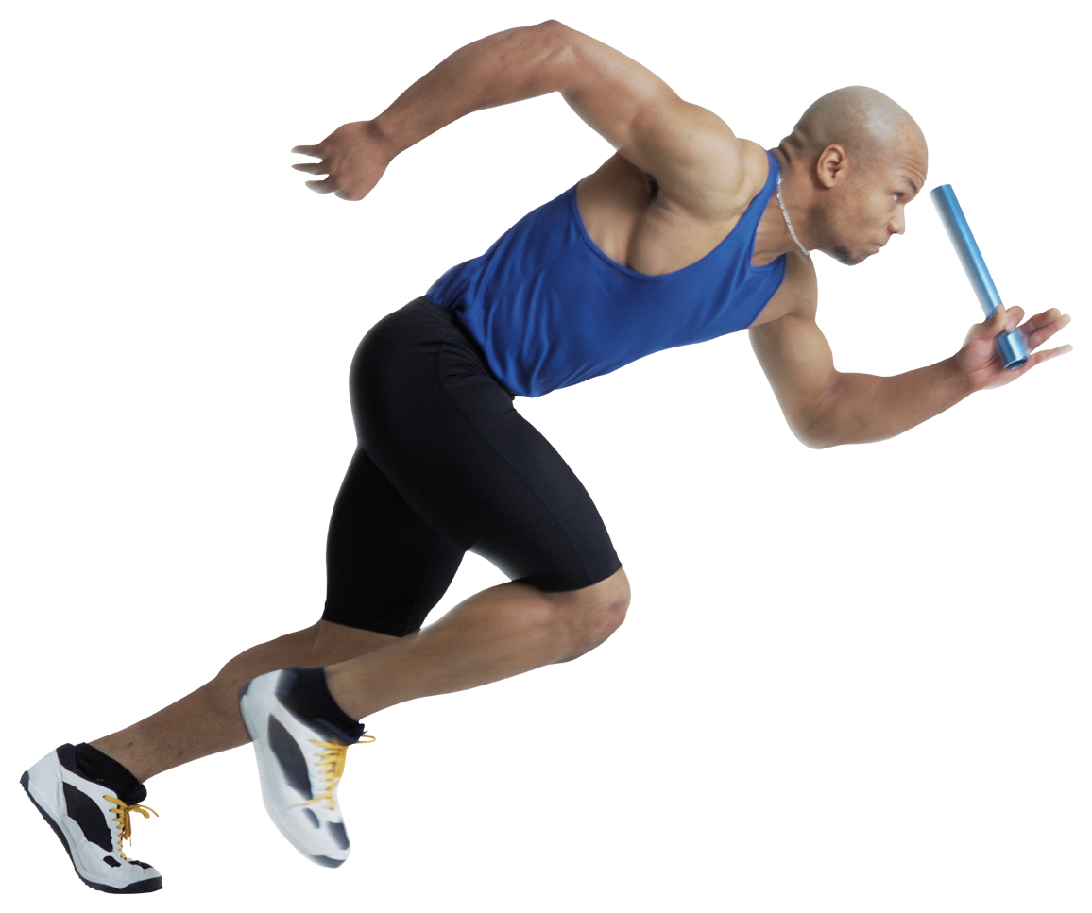

“A bear, however hard he tries, grows tubby without exercise.”
~ A. A. Milne, Winnie-the-Pooh
THE FINANCIAL PLAN
PART 5

- Complete the budget form below (a version is available in Excel which will do the calculations for you).

- Please be as accurate as possible with the figures. A well thought out budget can save you from anxiety and financial distress.

- Have your parent look over the figures before you print your final copy. Consider any changes he/she might suggest to make the figures more accurate (especially family contributions).

- If you have a similar budget sheet, please check with your teacher to see if you can use it in place of this recommended form.

- Answer the questions that follow the budget in paragraph form in a word-processed document.

- Place the verified budget and questions (printouts) in your GT binder.

 | Due Dates:
Budget: | ____________________________
Questions: | ____________________________

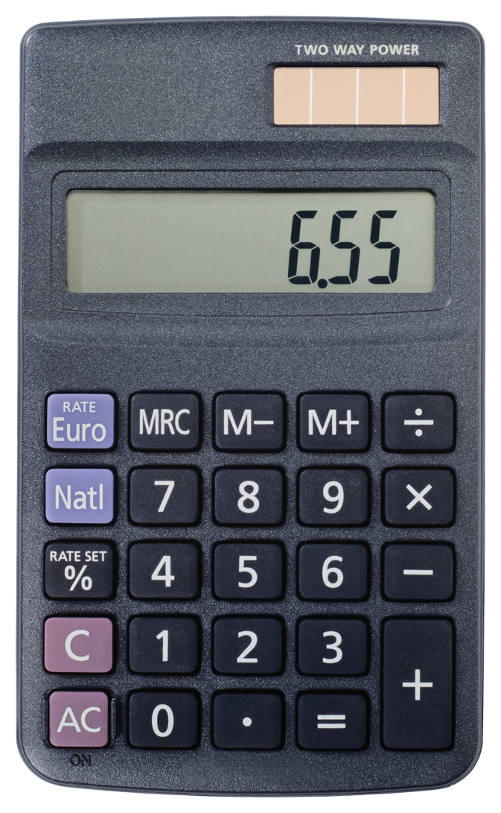

The importance of money flows from it being a link between the present and the future.”
~ John Maynard Keynes

GRADUATION TRANSITION YEAR BUDGET
For the Year Ended (month/year)
All figures should reflect the cost for 12 months (one year).
Do not show any amounts that have not been calculated for a twelve month period.
Do not show dollar signs: align numbers at the decimal point. THIS DOCUMENT IS AVAILABE IN EXCEL AND CAN BE
COMPLETED ELECTRONICALLY. PRINT OUT THE BUDGET WHEN FINALIZED.
 |  | ($)
INCOME (All income you can generate over 12 months)
Earnings from employment |  | .00
Investment income (interest/dividends) |  | .00
Contributions from Parents/Family |  | .00
Student Loans |  | .00
Gifts |  | .00
Scholarships/Bursaries |  | .00
RESP or other savings plan |  | .00
Other income |  | .00
TOTAL INCOME: |  | .00
EXPENSES (calculate for 12 months) |  | .00
FIXED EXPENSES
Rent/Residence housing |  | .00
Utilities (hydro electric, gas, water, garbage) |  | .00
Cable and Internet |  | .00
Cell phone or land line |  | .00
Banking fees |  | .00
Borrowing costs (interest on loans) |  | .00
Car Insurance |  | .00
Bus Passes (if not included in tuition) |  | .00
Planned savings |  | .00
Other fixed expenses (list) |  | .00
Other fixed expenses (list) |  | .00

GT BUDGET, page 2
For the year ended (month/year)

VARIABLE EXPENSES
Tuition fees (annual) | .00
Books/supplies | .00
Tools, equipment | .00
Computer & printer expenses | .00
Food/meal plan | .00
Personal care (toiletries/hair/nails) | .00
Transportation (taxi/gas) | .00
Bus passes/fares | .00
Long Distance charges | .00
Restaurant meals | .00
Snacks/coffees/sodas | .00
Household (cleaning supplies/dishes/furniture/decorating) | .00
Clothing (purchases/repairs/dry cleaning) | .00
Laundry | .00
Insurance (health, travel, medical, content) | .00
Travel costs (including travel home) | .00
Fitness fees/passes | .00
Entertainment | .00
Gifts | .00
Other variable expenses (list) | .00
Other variable expenses (list) | .00
TOTAL EXPENSES (Fixed and variable) | .00
TOTAL INCOME less TOTAL EXPENSES | .00
BUDGET SURPLUS (greater than zero) | .00
BUDGET DEFICIT (Less than zero) | .00
CHECK: ARE ALL THE FIGURES CALCULATED ON AN ANNUAL BASIS (no monthly amounts)? Round all figures to the nearest dollar.

CAREER AND LIFE
Financial Planning Questions

Answer the following questions in paragraph form, using a word processor.

- Why should I bother with a budget?
- How will I keep track of the money coming in and going out?
- What can I/have I learn(ed) from managing my own finances?
- Choose one, depending on your bottom line – surplus or deficit:
  - What will I do with the surplus?
  - How will I deal with the deficit?

This budget must be approved by a parent. Parents, please check over the figures to verify that they are amounts for your son/daughter’s income and expenses are reasonable (particularly the family contribution). Please advise him/her of any changes you foresee so that this budget can accurately reflect his/her financial position for next year. Your signature indicates to the teacher that you have reviewed this final budget for you son’s/daughter’s first year (12 months) following high school.

Parent Signature: ______________________________________ Date: _____________________
Student Signature: ______________________________________ Date: _____________________
Student Name (print): ______________________________________

Reminder: Questions accompany this budget assignment (see top of page).

PART 6
COMMUNITY CONNECTIONS

This section involves your preparation and evidence of participation in the work force. You will provide evidence of your community involvement through work or volunteer evaluations, pay stubs and your reflections on your work. In preparation for the working life, you are required to prepare and submit an updated resume in good form.

Resume: See class notes on how to prepare a resume in good form. If you missed the class on resumes, see your GT teacher or a classmate for resume writing tips.

Cover Letter: Must be in business letter format. See your class notes on how to write a cover letter.

Requirements: | Due Date
- Supervisors’ Report on Student Volunteer or Employee
- Two reference letters from someone outside of your family who has experience working with you (employer, teacher, parish priest, volunteer supervisor)
- An updated resume in good form
- A cover letter in business letter format
- Proof of a least 30 hours of volunteer or paid work (supervisors’ reports or pay stubs)
- Employability Skills: Student Self-Evaluation and Reflection form

Hard work beats talent when talent doesn't work hard. ~ Tim Notke

SUPERVISOR’S REPORT ON STUDENT VOLUNTEER or EMPLOYEE
St. Thomas Aquinas High School, North Vancouver, BC

To be completed by the SUPERVISOR ONLY in INK. **Please provide student with a business card.

Student’s Name: _____________________________________________ Date of Placement: ____________________________________________
Supervisor’s Name: __________________________________________ Position: _______________________________________________________
Evaluator’s Phone: __________________________________ Evaluator’s Email: ____________________________________________
Hours completed (as accurately as possible) ___________________________ Signature: ________________________________________ Date: __________________

This student is requesting that experiences gained at your organization by accepted for school credit towards Work Experience. Your constructive assessment enables us to determine whether credit is earned. Please evaluate the student by circling the number that BEST represents his/her performance.

(5) Excellent (4) Good (3) Satisfactory (2) Fair (1) Poor (NA) Not Applicable

 | Excellent |  |  |  | Poor |  |  | Comment (optional)
Fundamental Skills
Is able to solve problems | 5 | 4 | 3 | 2 |  | 1 | NA | __________________________________________________________
Follows directions-listens to understand (and learn) | 5 | 4 | 3 | 2 |  | 1 | NA | __________________________________________________________
Communicates well with colleagues and public | 5 | 4 | 3 | 2 |  | 1 | NA | __________________________________________________________
Uses technology effectively | 5 | 4 | 3 | 2 |  | 1 | NA | __________________________________________________________
Recognizes problems and effectively deals with them | 5 | 4 | 3 | 2 |  | 1 | NA | __________________________________________________________
Personal Management Skills |  |  |  |  |  |  |  | __________________________________________________________
Attendance and Punctuality | 5 | 4 | 3 | 2 |  | 1 | NA | __________________________________________________________
Dresses appropriately | 5 | 4 | 3 | 2 |  | 1 | NA | __________________________________________________________
Honest and Ethical (including confidentiality) | 5 | 4 | 3 | 2 |  | 1 | NA | __________________________________________________________
Shows enthusiasm | 5 | 4 | 3 | 2 |  | 1 | NA | __________________________________________________________
Adjusts to new situations | 5 | 4 | 3 | 2 |  | 1 | NA | __________________________________________________________
Manages time effectively | 5 | 4 | 3 | 2 |  | 1 | NA | __________________________________________________________
Works independently | 5 | 4 | 3 | 2 |  | 1 | NA | __________________________________________________________
Concentrates on tasks | 5 | 4 | 3 | 2 |  | 1 | NA | __________________________________________________________
Demonstrates safe work practices | 5 | 4 | 3 | 2 |  | 1 | NA | __________________________________________________________
Teamwork Skills |  |  |  |  |  |  |  | __________________________________________________________
Works well with other employees respecting diversity | 5 | 4 | 3 | 2 |  | 1 | NA | __________________________________________________________
Shows initiative where appropriate | 5 | 4 | 3 | 2 |  | 1 | NA | __________________________________________________________
Accepts constructive feedback | 5 | 4 | 3 | 2 |  | 1 | NA | __________________________________________________________
Participates effectively in projects and tasks | 5 | 4 | 3 | 2 |  | 1 | NA | __________________________________________________________
Has a positive attitude towards duties | 5 | 4 | 3 | 2 |  | 1 | NA | __________________________________________________________

- Does this student have the aptitudes necessary to become a good employee? (circle) Yes Possibly No NA
- Do you think your business field would be appropriate for this student? (circle) Yes Possibly No NA
- Supervisor’s comments or recommendations:
_______________________________________________________________________________________________________________________________________________
_______________________________________________________________________________________________________________________________________________
_______________________________________________________________________________________________________________________________________________
_______________________________________________________________________________________________________________________________________________
STUDENT SELF-EVALUATION & REFLECTION
St. Thomas Aquinas High School, North Vancouver, BC

To be completed by the STUDENT ONLY in INK.

Student Name: _______________________________________________ GT Teacher: _________________________________________
Homeroom Teacher: _________________________________________

- Describe the nature of the work experience you did:
_______________________________________________________________________________________________________________________________________________
_______________________________________________________________________________________________________________________________________________
_______________________________________________________________________________________________________________________________________________
_______________________________________________________________________________________________________________________________________________
- Describe in detail how you acquired this work:
_______________________________________________________________________________________________________________________________________________
_______________________________________________________________________________________________________________________________________________
_______________________________________________________________________________________________________________________________________________
_______________________________________________________________________________________________________________________________________________
_______________________________________________________________________________________________________________________________________________
_______________________________________________________________________________________________________________________________________________
- In point form, list the job duties you had to perform:
- _______________________________________________________________________________________________________________________________________________
- _______________________________________________________________________________________________________________________________________________
- _______________________________________________________________________________________________________________________________________________
- _______________________________________________________________________________________________________________________________________________
- _______________________________________________________________________________________________________________________________________________
- _______________________________________________________________________________________________________________________________________________
- _______________________________________________________________________________________________________________________________________________
- _______________________________________________________________________________________________________________________________________________
- _______________________________________________________________________________________________________________________________________________
- What did you most enjoy about this work experience and why?
_______________________________________________________________________________________________________________________________________________
_______________________________________________________________________________________________________________________________________________
_______________________________________________________________________________________________________________________________________________
_______________________________________________________________________________________________________________________________________________
- What was your greatest challenge and why?
_______________________________________________________________________________________________________________________________________________
_______________________________________________________________________________________________________________________________________________
_______________________________________________________________________________________________________________________________________________
_______________________________________________________________________________________________________________________________________________
_______________________________________________________________________________________________________________________________________________

THIS DOCUMENT NEED NOT BE WORD PROCESSED – BUT PLEASE FILL IT OUT NEATLY, IN INK!
Following is a list of skills, attitudes and behaviours necessary for successful employment. Please evaluate yourself on how you see yourself at this time. Circle the number that BEST represents your performance at a job (volunteer or paid).

(5) Excellent (4) Good (3) Satisfactory (2) Fair (1) Poor (NA) Not Applicable

 | Excellent |  |  |  | Poor |  |  | Comment (optional)
Fundamental Skills
Is able to solve problems | 5 | 4 | 3 | 2 |  | 1 | NA | __________________________________________________________
Follows directions-listens to understand (and learn) | 5 | 4 | 3 | 2 |  | 1 | NA | __________________________________________________________
Communicates well with colleagues and public | 5 | 4 | 3 | 2 |  | 1 | NA | __________________________________________________________
Uses technology effectively | 5 | 4 | 3 | 2 |  | 1 | NA | __________________________________________________________
Recognizes problems and effectively deals with them | 5 | 4 | 3 | 2 |  | 1 | NA | __________________________________________________________
Personal Management Skills |  |  |  |  |  |  |  | __________________________________________________________
Attendance and Punctuality | 5 | 4 | 3 | 2 |  | 1 | NA | __________________________________________________________
Dresses appropriately | 5 | 4 | 3 | 2 |  | 1 | NA | __________________________________________________________
Honest and Ethical (including confidentiality) | 5 | 4 | 3 | 2 |  | 1 | NA | __________________________________________________________
Shows enthusiasm | 5 | 4 | 3 | 2 |  | 1 | NA | __________________________________________________________
Adjusts to new situations | 5 | 4 | 3 | 2 |  | 1 | NA | __________________________________________________________
Manages time effectively | 5 | 4 | 3 | 2 |  | 1 | NA | __________________________________________________________
Works independently | 5 | 4 | 3 | 2 |  | 1 | NA | __________________________________________________________
Concentrates on tasks | 5 | 4 | 3 | 2 |  | 1 | NA | __________________________________________________________
Demonstrates safe work practices | 5 | 4 | 3 | 2 |  | 1 | NA | __________________________________________________________
Teamwork Skills |  |  |  |  |  |  |  | __________________________________________________________
Works well with other employees respecting diversity | 5 | 4 | 3 | 2 |  | 1 | NA | __________________________________________________________
Shows initiative where appropriate | 5 | 4 | 3 | 2 |  | 1 | NA | __________________________________________________________
Accepts constructive feedback | 5 | 4 | 3 | 2 |  | 1 | NA | __________________________________________________________
Participates effectively in projects and tasks | 5 | 4 | 3 | 2 |  | 1 | NA | __________________________________________________________
Has a positive attitude towards duties | 5 | 4 | 3 | 2 |  | 1 | NA | __________________________________________________________

- Explain how your work experience has helped you to develop the above skills:
_______________________________________________________________________________________________________________________________________________
_______________________________________________________________________________________________________________________________________________
_______________________________________________________________________________________________________________________________________________
_______________________________________________________________________________________________________________________________________________
_______________________________________________________________________________________________________________________________________________
_______________________________________________________________________________________________________________________________________________
_______________________________________________________________________________________________________________________________________________

- How does this work experience relate to your career goals for the future?
_______________________________________________________________________________________________________________________________________________
_______________________________________________________________________________________________________________________________________________
_______________________________________________________________________________________________________________________________________________
_______________________________________________________________________________________________________________________________________________
_______________________________________________________________________________________________________________________________________________

__________________________________________________ ____________________
Student’s Signature Date of Signature

THIS DOCUMENT NEED NOT BE WORD PROCESSED – BUT PLEASE FILL IT OUT NEATLY, IN INK!
Employability Skills Reflection

* This assignment must be completed only after you have completed your work experience and your Student Self-Evaluation & Reflection form.

Consider your work and volunteer experiences since Grade 10. State and describe the various skills you have developed from having done these. Your responses must be word-processed.

- Using the BULLETED (not bolded) skills on the Employability Skills 2000+ chart, identify and state three skills you have acquired and developed under categories A, B, and C (total – nine skills). As you list these, describe HOW and WHERE you developed each of these skills.

Employability Skill Category | Skill Acquired | How you Acquired it | Where you Acquired it
CATEGORY A  Fundamental Skills | 1.
 | 2.
 | 3.
CATEGORY B  Personal Management Sills | 1.
 | 2.
 | 3.
CATEGORY C  Teamwork Skills | 1.
 | 2.
 | 3.

Refer to the job duties list on your Student Self-Evaluation & Reflection form.
- How did these duties help you to develop the skills you listed above? Try to be specific by describing situations that aided you in developing these skills.
- How have these experiences and skills that you acquired benefitted you, and how might they transfer to future experiences?
- Explain how your work/volunteer experiences have benefitted or contributed to the community.
DAILY PHYSICAL ACTIVITY REPORT
VERIFICATION FORM

Circle the one that applies:

REPORT 1 | REPORT 2 | REPORT 3

LAST NAME: _____________________________________ FIRST NAME:____________________________________
(PRINT LEGIBLY)

GRADE: _________ HOMEROOM TEACHER: ________________________ DATE: _____________________
This reporting period I have taken one of these courses to partially complete the DPA requirements: PE 10, 11, 12 or other (please list):
__________________________________________________________________________________________
This period, I participated in the following school sports (please list):
___________________________________________________________________________________________
__________________________________________________________________________________________
This period, I participated in the following extra-curricular activities, (e.g. Intramurals, school outings, etc.) (please list):
__________________________________________________________________________________________
__________________________________________________________________________________________
This period, I participated in the following community organized programs (list):
__________________________________________________________________________________________
__________________________________________________________________________________________
This term I participated in physical activities at home or in the community that included (e.g. Swimming, jogging, walking, biking, weight training, etc.) (please list):
__________________________________________________________________________________________
__________________________________________________________________________________________
Other (please list):
__________________________________________________________________________________________

I acknowledge my responsibility to record/document my involvement in daily physical activity and have the support of my family to ensure the completion of this Graduation Requirement according to the BC Ministry of Education.

Student Signature: ____________________________________________ Date: ______________________
Parent Signature: ____________________________________________ Date: ______________________

SUBMIT THIS FORM TO YOUR HOMEROOM TEACHER.
DAILY PHYSICAL ACTIVITY REPORT
VERIFICATION FORM

Circle the one that applies:

REPORT 1 | REPORT 2 | REPORT 3

LAST NAME: _____________________________________ FIRST NAME:____________________________________
(PRINT LEGIBLY)

GRADE: _________ HOMEROOM TEACHER: ________________________ DATE: _____________________
This reporting period I have taken one of these courses to partially complete the DPA requirements: PE 10, 11, 12 or other (please list):
__________________________________________________________________________________________
This period, I participated in the following school sports (please list):
___________________________________________________________________________________________
__________________________________________________________________________________________
This period, I participated in the following extra-curricular activities, (e.g. Intramurals, school outings, etc.) (please list):
__________________________________________________________________________________________
__________________________________________________________________________________________
This period, I participated in the following community organized programs (list):
__________________________________________________________________________________________
__________________________________________________________________________________________
This term I participated in physical activities at home or in the community that included (e.g. Swimming, jogging, walking, biking, weight training, etc.) (please list):
__________________________________________________________________________________________
__________________________________________________________________________________________
Other (please list):
__________________________________________________________________________________________

I acknowledge my responsibility to record/document my involvement in daily physical activity and have the support of my family to ensure the completion of this Graduation Requirement according to the BC Ministry of Education.

Student Signature: ____________________________________________ Date: ______________________
Parent Signature: ____________________________________________ Date: ______________________

SUBMIT THIS FORM TO YOUR HOMEROOM TEACHER.
DAILY PHYSICAL ACTIVITY REPORT
VERIFICATION FORM

Circle the one that applies:

REPORT 1 | REPORT 2 | REPORT 3

LAST NAME: _____________________________________ FIRST NAME:____________________________________
(PRINT LEGIBLY)

GRADE: _________ HOMEROOM TEACHER: ________________________ DATE: _____________________
This reporting period I have taken one of these courses to partially complete the DPA requirements: PE 10, 11, 12 or other (please list):
__________________________________________________________________________________________
This period, I participated in the following school sports (please list):
___________________________________________________________________________________________
__________________________________________________________________________________________
This period, I participated in the following extra-curricular activities, (e.g. Intramurals, school outings, etc.) (please list):
__________________________________________________________________________________________
__________________________________________________________________________________________
This period, I participated in the following community organized programs (list):
__________________________________________________________________________________________
__________________________________________________________________________________________
This term I participated in physical activities at home or in the community that included (e.g. Swimming, jogging, walking, biking, weight training, etc.) (please list):
__________________________________________________________________________________________
__________________________________________________________________________________________
Other (please list):
__________________________________________________________________________________________

I acknowledge my responsibility to record/document my involvement in daily physical activity and have the support of my family to ensure the completion of this Graduation Requirement according to the BC Ministry of Education.

Student Signature: ____________________________________________ Date: ______________________
Parent Signature: ____________________________________________ Date: ______________________

SUBMIT THIS FORM TO YOUR HOMEROOM TEACHER.
ST. THOMAS AQUINAS HIGH SCHOOL REPORT PERIOD 1 2 3
ACTIVITY LOG (Circle one)

Name: ______________________________________________

Homeroom Teacher: _______________________________

Students in grades 10-12 are required to document a minimum of 150 minutes of physical activity per week (moderate to vigorous intensity). Students may use this form to keep track of their physical activity each reporting period.

Keep accurate records for your Graduation Transitions binder. Your teacher may ask to see this report.

Activity | Approx. Hrs/week | Dates

