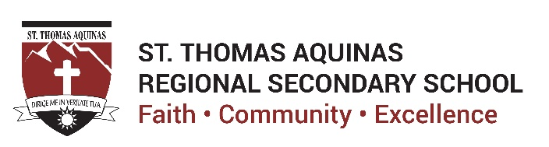

September 3, 2021

Dear Parents and Students of STA,

As you prepare to start the upcoming 2021-2022 school year, we wanted to provide you with some information about ongoing work on the school property. The duration of this work is not known at this time, however, safety fencing has been erected around the site.

On August 10, the Squamish Nation, Musqueam Nation and Tsleil-Waututh Nation together with representatives from the Archdiocese made a media statement on the school grounds. This is the link to the press release Squamish, Musqueam and Tsleil-Waututh Nations Announce Investigation at Former St. Paul’s Indian Residential School Site | Squamish Nation.

We especially honour and acknowledge those who attended, or had family members who attended St. Paul’s Indian Residential School. We are humbled to acknowledge their strength and resilience.

The former site of the St. Paul’s Indian Residential School and adjacent grounds were located roughly where the St. Thomas Aquinas Regional High School (STA) parking lot is situated.

Over the summer months, some landscaping and construction has been underway on the school property. This work is lead by St. Thomas Aquinas Regional High School and is supported by the Archdiocese, with all ground disturbance work being conducted in the presence of members of the Nation for their observation, guidance and response to arising needs.

The school and the Archdiocese have, and continue to work alongside members of the Squamish Nation to ensure that we can know and understand the truth of the history of the site of the former St. Paul’s Indian Residential School. The focus is to understand the full history of the site and, recognizing the site has been redeveloped many times, identify and recover any artifacts and or items or evidence of historical significance, should there be any.

Fencing has been installed around the area to protect the site and for the safety of the staff and students who will be back at school next week. The Squamish Nation have indicated that they will be using the fencing to post messaging about the investigative activities underway.

We, STA and RCAV, are grateful to the Squamish Nation for their engagement with us which is open, transparent and forward thinking as we collectively investigate the truths of this site. We have much to learn and act on in this journey of truth and reconciliation.

Here at STA we are committed to continuing to teach the truths of colonization and history of Residential Schools, including the role of the Catholic Church and other religious and government bodies in administering these institutions to all our students and we continue to work towards understanding and reconciliation.

STA will continue to follow the five commitments made by Archbishop Miller in his statements on May 28, 2021 and June 2, 2021 (see First Nations - Archdiocese of Vancouver (rcav.org). In these statements, the Archbishop also reiterated and reconfirmed the statement and commitments he made in 2013 in response to the Truth and Reconciliation Commission of Canada (“TRC”) Calls to Action.

In these responses and in the work that has followed, the Archbishop has emphasized his profound grief and apology for the intergenerational harms arising from the role of the Catholic Church in administering Residential Schools within the current and historic geographic areas of the Archdiocese of Vancouver; and, he has asserted his deep commitment to advancing on reconciliation commitments, in a way that honours the needs and ways of knowing of First Nations and Indigenous communities. As a member of the educational ministry of the Archdiocese, STA supports and follows in these commitments.

We thank the Elders, Council members, and Nation community members of Squamish, Musqueam and Tsleil-Waututh Nations, and everyone involved in this historic effort. We look forward to humbly learning more, continuing to collaborate as we move ahead in this important work of truth and reconciliation and sharing what we learn with our STA community.

Sincerely,

The Administration
St. Thomas Aquinas Regional Secondary School

